**Crear rama1**

JAIRO@dell MINGW64 ~/Desktop/curso (rama1)

$ git branch

master

* rama1

**Crear un fichero**

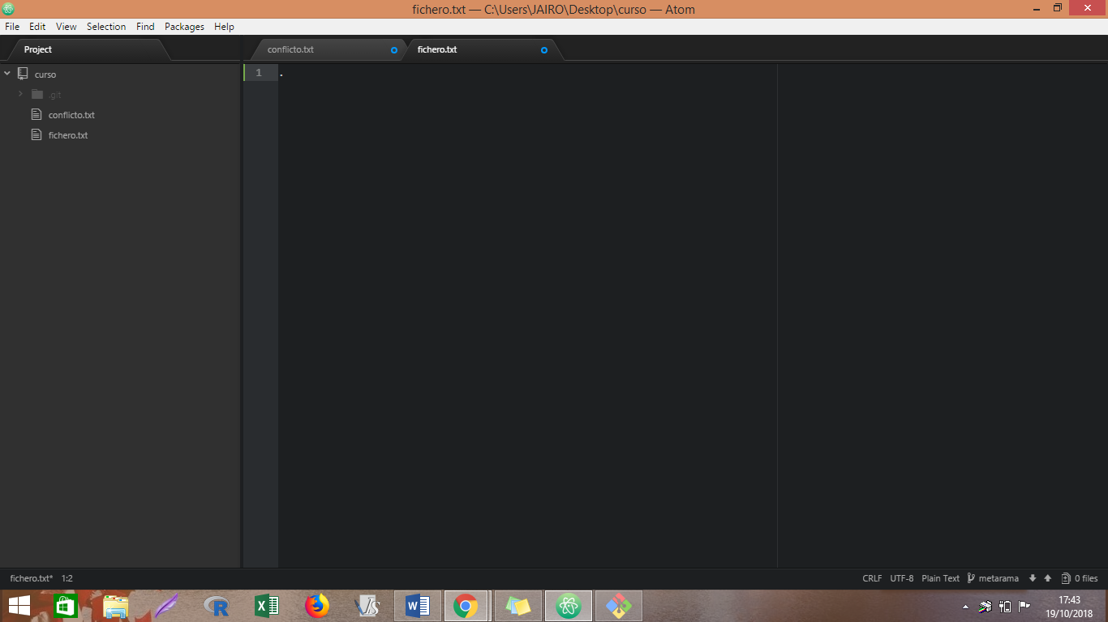

**Crear a partir de la rama, la metarama**

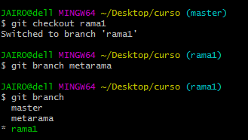

**REBASE**

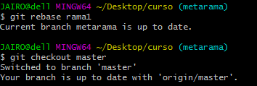

**Fusionar**

JAIRO@dell MINGW64 ~/Desktop/curso (master)

$ git merge rama1

Updating d4efb5c..169b978

Fast-forward

fichero.txt | 0

1 file changed, 0 insertions(+), 0 deletions(-)

create mode 100644 fichero.txt

***CAPTURA***

